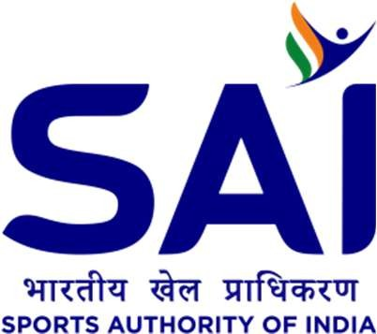

Press Release

Asian Games medallist Jyothi Yarraji to head to Spain as MOC approves foreign training plan for multiple TOPS athletes

New Delhi, April 11th: Ministry of Youth Affairs and Sports’ (MYAS) Mission Olympic Cell (MOC) during their latest meeting approved proposal of Asian Games medallist Jyothi Yarraji for financial assistance towards training in Spain.

Jyothi, who is currently ranked 23rd on Road to Paris list (Women’s 100m Hurdles event) is planning to train in Tenerife, Spain for 45 days to prepare for the upcoming season and Paris Olympics.

MOC, under its Target Olympic Podium Scheme (TOPS) funding will cover her airfare, boarding/ lodging cost, Visa application fees, facility access cost, sports massage expenditure, local transportation cost, OPA among other expenditure.

MOC also approved India shuttlers Chirag Shetty and Satwik Reddy’s proposal for financial assistance towards sparing partners to train ahead of the Paris Olympics.

MOC, under its TOPS funding will finance their training against Scottish pair of Alexander Dunn and Adam Hall and Indonesian pair Rain Agung and Berry Agriawan. The duo will train against the Scottish pair in Mumbai in June 2024 and the Indonesian pair in Hyderabad in July 2024 with TOPS funding the international pair’s airfare and boarding/ lodging costs.

Besides Jyothi, MOC also approved foreign training plans for Indian shooters Raiza Dhillon and Rajeshwari Kumari. While Raiza will train in in Italy with her personal coach Rajeshwari will in Italy train under coach David Kostelecky.
TOPS will be funding their and their coach’s airfare, accommodation cost, coaching fees, ammunition & Clay Birds expenditure, Visa and Gun Permit fee (for Raiza), extra baggage cost, local transportation cost among other expenditures. MOC also approved trap shooter Rajeshwari’s request for equipment upgrade, with TOPS funding her expenditure for a new Gun Stock.

Besides foreign exposure, MOC also approved proposal of Para-Shooters Rahul Jakhar and Rubina Francis for participation in the upcoming WSPS World Cup in Changwon South Korea.

TOPS will be funding their entry fees, entry fee for their coach, their boarding/lodging cost, local transport cost, expenditure for their gun permit, flight tickets, Visa, Insurance and OPA.

